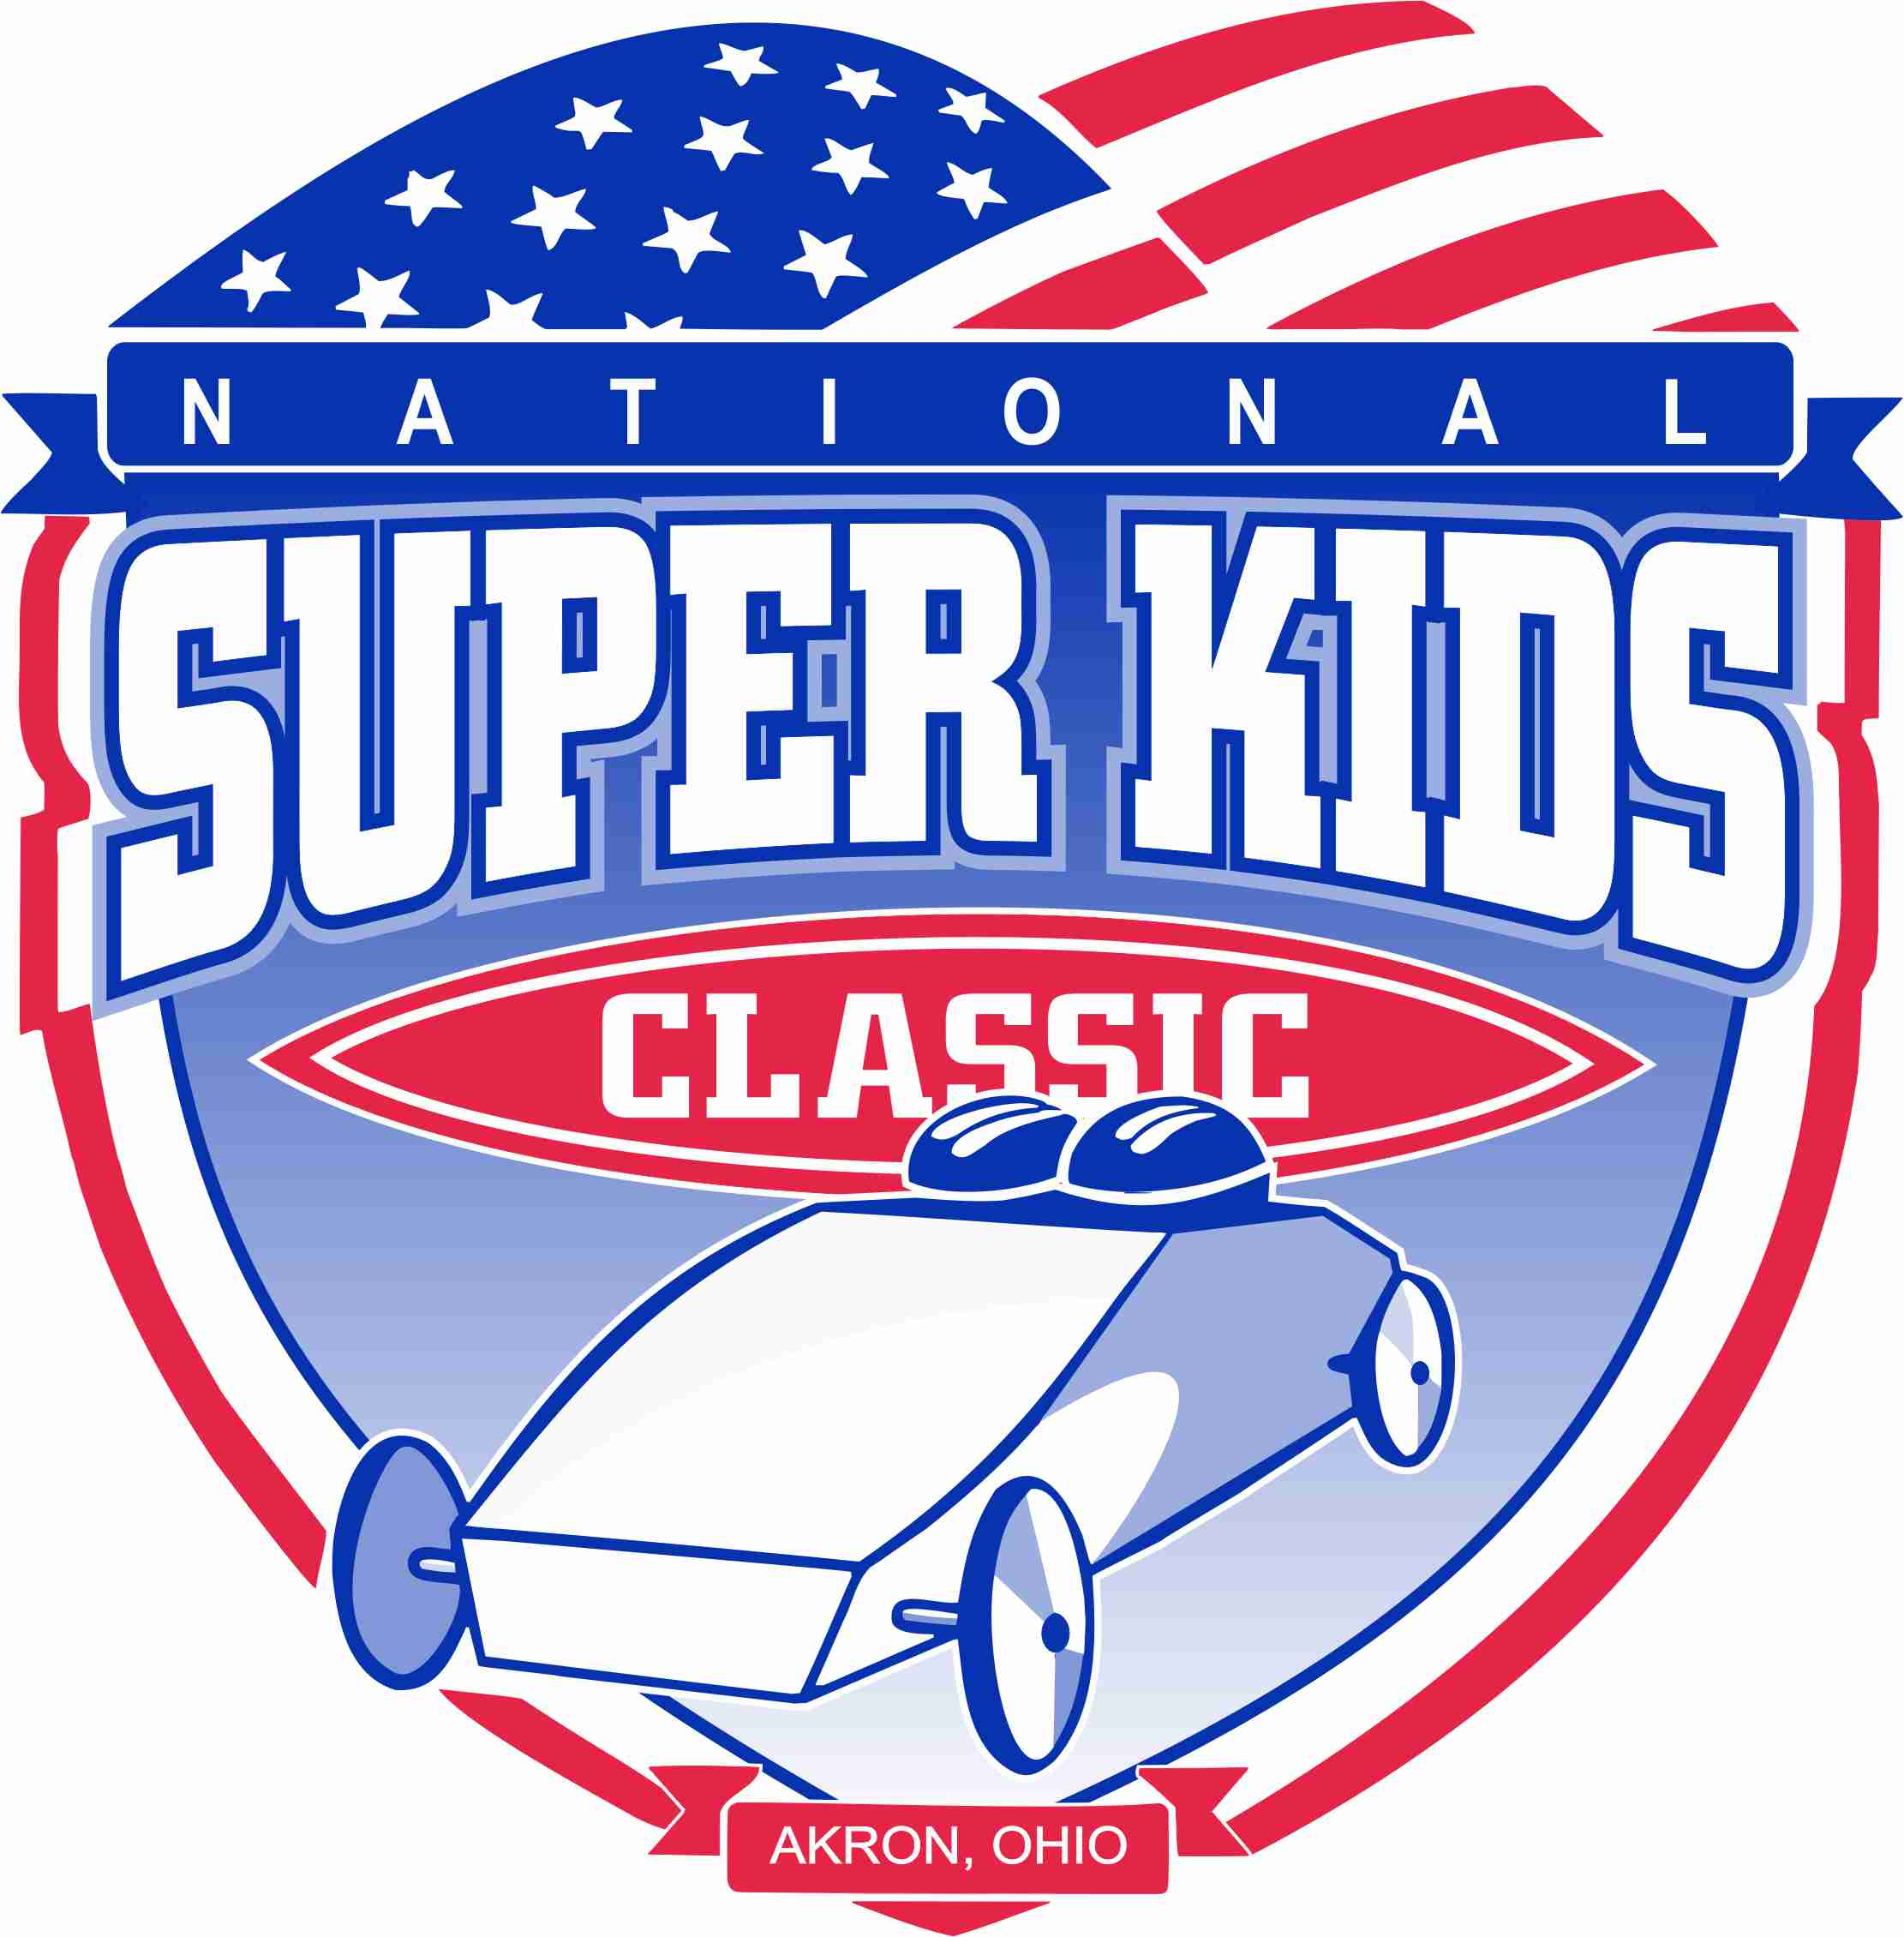

January 1, 2025

Dear All-American Soap Box Derby Directors:

This three (3) day event will begin with the Champion’s Banquet (for all of our champs) on Thursday, July 17, 2025. The National Super Kids Classic® race will kick off Friday morning; July 18, 2025. The final six (6) champs will race on Saturday, July 19, in conjunction with the All-American Soap Box Derby’s World Championships at Derby Downs, in Akron, Ohio.

Any city is eligible to hold a race for special needs youth or designate a local champion to send to Akron for competition in the National Super Kids Classic®. Your city sponsorship fee of $200.00 must be remitted by a business or organization, and received no later than April 30, 2025. Please make checks payable to National Super Kids Classic® and send to C/O Melanie Taylor, 3477 Cheyenne Trail NE, Hartville, Oh 44632. No personal checks accepted.

For the Champs continued safety a weight limit of 185 lbs. will continue for this year’s requirements.

Your local affiliate and/or community may designate and send a champion. The National Super Kids Classic® Board of Directors will provide one (1) room, two (2) nights lodging for one (1) champ and his/her parents/guardians.

Sincerely,
Mike Callahan, President
National Super Kids Classic® Board
330-376-9260 8:00 – 5:00 pm
Fax: 330-376-9307
E-mail: nationalsuperkids@gmail.com
---------------------------------------------------------------------------------------------------------------------------------------

(Please return portion below with reservation deposit)
Race Director Name_____________________________________Area______________________________
Should we continue to work through you? Yes___________________________No______________________
(If No please specify another contact)
Contact Information ________________________________________________________________________

Address _________________________________________________________________________________

City __________________________________________ St ___________ Zip_________________________

Phone: __________________________Email: ____________________________________

Date of your Local Race? _________________________________ Local Race Area __________________________
City Sponsorship fee of $200.00 MUST be paid by a business or organization by April 30, 2025. No
Personal checks accepted.

REGISTRATION PACKET CHECKLIST

Sponsor City Reservation (deadline April 30, 2025)

Race Participant Eligibility 3

Local Organization Responsibility 3

National Organization Responsibility 4

The following pieces constitute a complete registration packet and all must be completed in full and returned on or before the deadline by the Champs parents.

Registration Form & Parent Waiver 5
(Deadline July 1, 2025)
Scan and email to nationalsuperkids@gmail.com
Champion Biographical Information 6
(Deadline July 1, 2025)
Submit on line nationalsuperkids@gmail.com

Doctor Examination Form 7
(Deadline July 1, 2025)
Scan and email to nationalsuperkids@gmail.com
Champion Photo (of racer only, small enough for our program, school picture size, or racer in local race car maximum 4” x 6”)
Submit on line nationalsuperkids@gmail.com

Copy of Birth Certificate
Scan and email to nationalsuperkids@gmail.com

Photo Release Form (must be completed in full with permission) 8
Scan and email to nationalsuperkids@gmail.com
Release for Car Passengers (must be completed in full with permission) 9
Scan and email to nationalsuperkids@gmail.com

Hotel Reservation for the racer and their immediate family will be made by the National Super Kids board to ensure that the racers are at the host hotel, Hilton Garden Inn, 1307 East Market Street, Akron, Ohio 44305
NATIONAL SUPER KIDS CLASSIC®,

A SOAP BOX DERBY FOR YOUTHS WITH DISABILITIES

CHAMPION ELIGILIBILITY

-Must have a medically diagnosed disability, which a physician is willing to document
-Must be at least seven (7) years of age prior to local special needs race (7-18).
-May not exceed the weight limit of 185 lbs.
-May not have reached their 19th birthday prior to the national race date.
-May not be a current participant in ANY local or rally race division race for the All-American Soap Box Derby
-City Sponsorship fee of Two Hundred dollars ($200.00) non-refundable, made payable to National Super Kids Classic® as soon as possible but no later than April 30, 2025.
-All forms and fees must be mailed to: National Super Kids Classic®, C/O Melanie Taylor, 3477 Cheyenne Trail NE, Hartville, Ohio 44632. Please do not mail to any other address, we cannot assure receipt.

In the event that your special needs champion, for whatever reason, is unable to compete in the National Super Kids Classic® Soap Box Derby in Akron, Ohio, the Second-Place contestant may be accepted as an alternate and represent his/her local city as champion, provided all paperwork is completed and received by National Super Kids Classic® no later than July 1, 2025 and city sponsorship fee paid, as per above.

LOCAL ORGANIZATIONS

- Must adhere to eligibility guidelines as published from time to time
- Race format to be at discretion of local race organizations:
  - Style of derby cars, i.e. dual or single control, side by side seating, front to back seating, or a combination of both, at the discretion of local race organizations
  - Type of wheels, z-glass, steel, or a combination of both, at the discretion of local race organizations
  - Single or dual elimination race at the discretion of local race organizations
  - Number of contestants needed to qualify as a legal race to be determined by local race organizations
  - If dual control derby cars used, co-pilot drivers to be determined by local race organization. It is suggested that co-pilot drivers be limited to active local and/or rally soap box derby drivers to be selected by local race organizations
  - ONE special needs race champion per race city is eligible for the national race to be held at
Derby Downs, Akron, Ohio.
  - Local special needs race champions to be determined no later than July 1, 2025.
  - Registration forms and required paperwork for national race must be received within seventy-two (72) hours of completion of local special needs race and no later than July 1, 2025.
  - Information must include champion’s information, photo copy of birth certificate, signed parent (or guardian) consent forms as well as photo and passenger release forms and signed physician’s medical form

NATIONAL ORGANIZATION

- National Super Kids Classic®, the Soap Box Derby race for youths with disabilities, is to be held at Akron Derby Downs, Akron, Ohio, on Friday July 19, 2025.
- All derby cars will be provided for the race contestants by the NATIONAL ORGANIZATION.
- No derby cars of any type or style from local events will be accepted for the national competition at Akron, Ohio.
- Co-pilot drivers will be selected by the National Super Kids Classic® race director and provided for the competing champions.
- National race will be a double elimination event.
  - It will not be a time differential, wheel swap race.
  - It will consist of one run from starting line to finish line being considered a complete heat with the winner remaining in the Winner’s bracket, second place for that heat will be moved to the Challenger’s bracket to continue in competition.
- Heats will be two (2) car events.
- In the event of a bye, the champion may run that heat, unopposed, and remain in the winner’s bracket. This will be determined on race day by National Race Officials.
- Volunteers will be present to handle cars at the starting blocks, and run-out area. Parents are expected to supervise their own child while not racing.
- All contestants will be paired with a co-pilot driver, as near as possible, as to size and weight of his/her opponent and co-pilot for each heat in order to maintain equal and fair heats.
- Competing champions will be limited to the first one hundred (100) invitational respondents.
- All decisions of the National Super Kids Classic® Board of Directors will be final.
- All forms included in this packet must be completed in full and submitted by deadline of July 1, 2025.

Note: Area Race Director: If your race has not occurred by deadline, you must contact Melanie Taylor at nationalsuperkids@gmail.comor (234)425-3917 to make special arrangements.

NATIONAL SUPER KIDS CLASSIC® OFFICIAL REGISTRATION FORM

Local Champion Name _______________________________________________________
Address____________________________________________________________________
City______________________________________________ST_______Zip_____________
E-Mail ____________________________________________________________________
Telephone_______________________ Birth date______________ Male______ Female_____
Weight____________ T-Shirt size___________________ Youth__________ Adult_________
Disability___________________________ Special Equipment needed? _________________
If so what: _________________________________________________________________
If you have a wheelchair is it a soft, collapsible, or hard, electric? ______________________
Will you have a service dog? Yes______________ No_____________
Photo enclosed? Yes________No________Birth Certificate enclosed? Yes_____No______
I/We understand that the National Super Kids Classic® Organization, Board of Directors and/ or Officials retain the right to refuse to allow any child to participate in this event, should there be any question that participation in this National race may constitute an unsafe condition for that child or may threaten the safety of others participating in this National race.
Parent/Legal Guardian Signature________________________________________________
Print Name_________________________________________Date_____________________
___________________________________________________________________________

PARENT/GUARDIAN WAIVER
I/We, the parents or guardian of the above named child, for ourselves and on behalf of said minor child, hereby agree that said child’s participation in the National Super Kids Classic® shall be undertaken at your own risk and that the National Super Kids Classic® and it’s sponsors shall not be liable for any claims, injuries, or damages which might occur to said child, his/her property, honor to said parents/guardians arising out of or connected with said minor child’s participation in the National Super Kids Classic®.
It is understood this event is covered by media and you have voluntarily agreed that all photos and publicity are the property of and for the sole use of National Super Kids Classic®.

Signed: ____________________________________________Date_____________________

Relationship to participating child_______________________________________________

This form MUST be returned to: NATIONAL SUPER KIDS CLASSIC®, C/O Melanie Taylor, 3477 Cheyenne Trail NE, Hartville, Ohio 44632 by Registration deadline or child will not be eligible to participate.

ENTRIES WILL BE ACCEPTED ON A FIRST COME FIRST SERVED BASIS, LIMITED TO THE FIRST ONE HUNDRED (100) INVITATIONAL RESPONDING CHAMPIONS.

NATIONAL SUPER KIDS CLASSIC®
CHAMPIONS BIOGRAPHICAL SKETCH
Mailed in or submitted online at nationalsperkids.org under “Champs”.

Champion’s Name _____________________________________________________________________
Name Announcer should use _______________________ Race City_____________________________
School_________________ Grade _______ City__________________Favorite Subject____________ Favorite Color__________ Favorite Food_____________ Favorite Animal_________________
Favorite TV show_______________ Favorite Game_______________ Favorite Sport_______________
Favorite Activities_______________________ Favorite Music Artist___________________________
Sisters/Brothers ________________________________________________Ages______
Pets__________________________________________________________________________

Does your Champion have a special Hero/Heroine? ____________________________________
What information can you provide that is unique to your child that makes him/her a SUPER KID? You may want to express how previous experiences in this type of event or other special events have benefited your Champion. This information may be used in our program, along with the racer’s picture and may be considered for use in promotional spots for this event.
____________________________________________________________________________________________________________________________________________________________________________________________________________________________________________________________________________________________________________________________________________________________________________________________________________________________________________________________________________________________________________________________________________________________
NATIONAL SUPER KIDS CLASSIC®
DOCTOR’S EXAMINATION FORM
(TO BE COMPLETED BY PHYSICIAN)
Duplicate form if necessary

Participant’s Name: _______________________________________________________________
Age_________________Height__________________Weight___________________
Should there be any limitations placed on this child’s participation in The National Super Kids Classic®? Yes________________________ No____________________
Does this child have known allergies to any medications? ________________________

Are there any allergies to food? ____________________________________________

Recommendations: (use attachment if necessary) __________________________________________________________________________________________________________________________________________________________I have on this date_______________________________examined the above participant and on the basis of my examination, as requested by the National Super Kids Classic® officials and his/her medical history as furnished to me, I find no reason which would make it medically inadvisable for this child to compete in a supervised soap box derby activity. (Note exceptions above).
Physician’s Signature___________________________________________________
Name print) ___________________________________________________________
Address___________________________________City_______________________
St_________ Zip __________ Telephone _____________________________________

Doctor: PLEASE DELIVER THIS FORM TO ABOVE NAMED CHILD’S PARENT/GUARDIAN FOR INSERTION IN OFFICIAL REGISTRATION PACKET. THERE IS A DEADLINE SO PLEASE DON’T DELAY.

PHOTOGRAPH RELEASE FORM

In consideration of my child's picture being taken, upon the terms hereinafter stated, I hereby grant the National Super Kids Classic® and committee, their legal representatives and/or designates the absolute right and permission to copyright and use, reuse and publish, and republish photographic portraits or pictures of (stated child) in which they may be included, in whole or in part, or composite or distorted alterations from time to time, in conjunction with his/her own or a fictitious name, or reproductions thereof in color or otherwise made through any media at his studios or elsewhere for art, advertising, trade or any other purpose beneficial to the National Super Kids Classic®.

I also consent to the use of any printed matter in conjunction therewith.

I hereby waive any right that I may have to inspect or approve the finished product or products or the advertising copy or printed matter that may be used in connection therewith or the use to which it may be applied.

I hereby release, discharge and agree to save harmless National Super Kids Classic® and all Board members, committee members, their legal representatives or assigns, and all persons acting under their permission or authority or those for whom they are acting, from any liability by virtue of any blurring, distortion, alteration, optical illusion, or use in composite form, whether intentional or otherwise that may occur or be produced in the taking of said picture or in any subsequent processing thereof, as well as any publication thereof.

I hereby warrant that I am the parent/legal guardian of said child and state that I have read the above authorization, release, and agreement prior to its execution, and that I am fully familiar with the contents thereof.

(Champion’s name)

(Parent/guardian signature)

This form must be completed in full before your child may participate.

phorelfm.doc

NATIONAL SUPER KIDS CLASSIC®

Release for Car Passengers

In consideration of being permitted to participate in any event sponsored, promoted, or directed by National Super Kids Classic,® (“NSK”), the undersigned, passengers for himself/herself, his/her personal representatives, heirs and next of kin HEREBY RELEASES NSK and its respective parent corporations, subsidiaries, officers, directors, promoters, sponsors, employees, volunteers and agents (“releasees”) of all liability to the undersigned, whether caused by the negligent act or omission of releasees or otherwise while the undersigned is for any purpose a passenger in a vehicle driven by releasees. It is fully understood by the undersigned that there is some inherent risk associated with transportation, including damage to vehicles, or to persons, during transportation to airports, hotels and to the location of the event. IN ADDITION, the undersigned AGREES TO HOLD HARMLESS the releasees from any loss, liability, damage, or cost they incur due to being a passenger in a vehicle of releasees, and any passengers (including minors) whether caused by releasees’ negligence or otherwise, and AGREES TO ASSUME FULL RESPONSIBILITY AND RISK for any bodily injury, death, or property damage from releasees’ negligence or otherwise while the undersigned is a passenger in one of releasees vehicles. In signing this release, each of the undersigned hereby acknowledges and represents the following:

1. That he or she has read the foregoing Release and Waiver
of Liability and Indemnity Agreement; and understands that
he/she is assuming liability for their own personal or bodily
damage that may occur during an accident.

2. That he or she shall at all times, while riding in a vehicle
participating in this event, wear his or her respective seat and
shoulder belts.

3.That the owner/driver certifies that he/she has inspected
this vehicle and it is in good mechanical condition.

For minors participating in the event, one parent with legal custody or the minor’s legal guardian must sign this release form on the minor’s behalf and write the word “minor” and age next to the minor’s name.

__________________________________________
Participant’s Name

Name Date

This form must be completed in full before your child may participate.

